TASK 3 - SHREYA SHENOY

**Type**: MySQL

**ER Diagram**:

|  |
| --- |
|  |

**Create Statements**:

CREATE TABLE IF NOT EXISTS `neighbouringNodes` (

`nID` int(11) NOT NULL AUTO_INCREMENT,

`size` int(2) NOT NULL,

`debug` tinyint(1) NOT NULL,

PRIMARY KEY (nID)

) ENGINE=InnoDB DEFAULT CHARSET=latin1;

CREATE TABLE IF NOT EXISTS `shape` (

`shapeID` int(11) NOT NULL AUTO_INCREMENT,

`type` varchar(11) NOT NULL,

PRIMARY KEY (shapeID)

) ENGINE=InnoDB DEFAULT CHARSET=latin1;

CREATE TABLE IF NOT EXISTS `grid` (

`gridID` int(11) NOT NULL AUTO_INCREMENT,

`nID` int(11) NOT NULL,

`shapeID` int(11),

`originIndex` int(11),

`radius` int(11),

PRIMARY KEY (gridID)

) ENGINE=InnoDB DEFAULT CHARSET=latin1;

**Add Foreign keys:**

ALTER TABLE `grid`

ADD CONSTRAINT `grid_ibfk_1` FOREIGN KEY (`nID`) REFERENCES `neighbouringNodes` (`nID`),

ADD CONSTRAINT `grid_ibfk_2` FOREIGN KEY (`shapeID`) REFERENCES `shape` (`shapeID`);

**Insert Statement**:

INSERT INTO `shape` (`type`) VALUES

('cross'),

('diamond'),

('square');

INSERT INTO `grid` (`gridID`, `nID`, `shapeID`, `originIndex`, `radius`) VALUES

(1, 1, 1, 5, 1),

(2, 3, 2, 25, 3),

(3, 3, 3, 31, 2);

INSERT INTO `neighbouringNodes` (`nID`, `size`, `debug`) VALUES

(1, 3, 1),

(2, 4, 0),

(3, 7, 1),

(4, 9, 0);

**Select Statement**:

SELECT * FROM grid WHERE nID=3 ORDER BY radius ASC

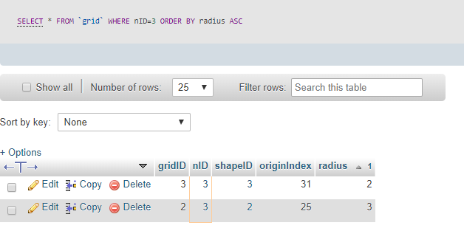

SELECT * FROM grid INNER JOIN neighbouringNodes ON grid.nID=neighbouringNodes.nID WHERE neighbouringNodes.size >5;

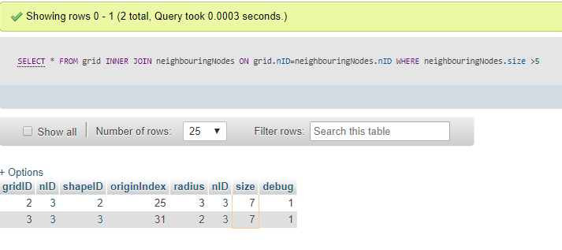

SELECT * FROM grid INNER JOIN shape ON grid.shapeID=shape.shapeID WHERE shapeID = 2;

